**IT ASSIGNMENT**

**NAME-PATEL DHARA JANAKBHAI**

**ROLL NO-141**

1.Explain Green Computing with its advantages.

Green computing sometimes also called Green Technology. In the green computing we use computer and its related other resources such as monitor, printer, hard disk, floppy disk, networking in very efficiently manner which has less impact on the environment. Green computing is about eco-friendly use of computer. Green computing is important for all type of system. It is important for handheld system to large scale data centre.

Many IT companies have been start the use of green computing to reduce the environment impact of their IT operations . Green computing is the emerging practice of using computing and information technology resources more efficiently while maintaining or improving overall performance. The concept identifies the barriers and benefits of green computing.

Green computing is an environment friendly approach to manage information and communication technology. In active organization to increasing energy efficiently, improving information management. Designing objects and services that are beneficial for the environment.

*ADVANTAGES OF GREEN COMPUTING:

1) Green computing technique reduces the energy consumption which results into low carbon dioxide emission.

2) By using green computing techniques we can also save money that was spent in extra usage of energy and resources.

3) Green computing also applies changing government policy to encourage recycling.

4) Green computing also removes the risk which is existing in the laptop such as chemical known to cause cancer or nerve damage etc.

5) Use preserve resources which use less energy to produce use and dispose of product.

2. What is E-waste? What can be done to reduce the impact of E-waste.

E-waste is electronic products that are unwanted, not working, and nearing or at the end of their “useful life.” Computers, televisions, VCRs, stereos, copiers, and fax machines are everyday electronic products.

The ongoing challenge of how best to dispose of used and unwanted electronics isn’t a new one and dates back at least to the 1970s. But a lot has changed since then, particularly the number of electronics being discarded today.

We also have something else today: a term for this issue. After several terms got suggested, including “Digital rubbish,” a consensus formed around the simple word “e-waste.”

E-waste is any electrical or electronic equipment that’s been discarded. This includes working and broken items that are thrown in the garbage or donated to a charity reseller like Goodwill. Often, if the item goes unsold in the store, it will be thrown away. E-waste is particularly dangerous due to toxic chemicals that naturally leach from the metals inside when buried.

## **Donate or Sell Working Electronics**

One simple way to efficiently manage e-waste is to simply sell your working electronics. You may find a buyer via eBay or Craigslist. Many of these buyers will use them, resell them, or use / sell the parts. Otherwise, there are recycling websites and comparison websites that will give you a price for your old gadgets and allow you to send them off, to be repurposed or recycled effectively.

Another great option is [Cell Phones for Soldiers](https://www.cellphonesforsoldiers.com/). Since 2004 Cell Phones For Soldiers has recycled more than 20 million cell phones, reducing the impact on landfills.

## **Consume Less in Order to Reduce Your E-Waste**

Of the 3 R’s (Reduce, Reuse, Recycle) [REDUCE is the most important](https://www.greenchildmagazine.com/go-green/). It’s so easy to purchase a sleek TV, the latest mobile phone, or a brand-new laptop. Most people don’t even stop to think if they really need them. Before buying anything, ask yourself whether you really need it. If you’re buying a new device even though your old one is in good working condition, why not simply upgrade the software? You can repair your old laptop instead of buying a new one. Being a sensible consumer will go a long way in productively managing your household’s e-waste.

## **Use Your Old Mobile Phone as a GPS Device**

Most people swap their old phones for a new one every year. Instead of letting it sit in the desk drawer, or worse, throwing it in the trash, consider using it for some other purpose. You can keep it in your car and [use it as a GPS device](https://www.recycleforlondon.com/five-ways-to-recycle-your-old-phone) or music player. Old phones can be converted into universal remote controls or used to monitor security cameras.

## **Recycle via a Retailer**

Major retailers and brands have in-store, online, and drop-off site recycling options. They recycle computers, mobile phones, and TVs. In fact, some will allow you to trade your obsolete equipment for gift cards. Before purchasing electronics, ask the store if they have a buyback program. Most large retailers give that option to customers.

## **Check E-Cycling Centres in Your State**

One way to reduce your e-waste is to give all your electronics that can’t be donated or resold to free sites. They have local groups that are moderated by local volunteers. Membership is free. Alternatively, you can collect all your e-waste once a month and give them away at an e-cycling centre in your state.

**3. What are the benefits of going paperless.**

## **1. Document organization**

The ability to quickly locate and disseminate information may enhance your company's efficiency and professional image. Spending time hunting through piles of paper slows down response time in an age when most answers are only a few keystrokes away. By scanning electronic copies of receipts and invoices, documents can be sorted, filed, and organized for quick retrieval when it matters most.

## **2. Client communication is faster and less expensive**

By maintaining a customer email list, you can instantaneously communicate sales and special offers without incurring postage and printing expenses. With the advanced technology of smart devices, most people have immediate access to emails. While it increases efficiency, electronic communication also decreases storage costs as the amount of paper copies littering your office will begin to dwindle.

## **3. Paperless files are easily saved and retrieved on the go**

With the advent of photo-scanning apps, business travellers can easily back up expense reports without needing to save a pile of papers to bring back to the office. Electronic files can also be shared with co-workers over a network or via email. Shifting to paperless documentation also makes the transportation of data more efficient, without the need for cumbersome fax machines or document couriers.

## **4. Automatic backups**

When you accidentally throw out an important paper, it's usually gone forever. However, maintaining electronic files allows for multiple backup points. Data can be saved on flash drives, in the cloud, or to an external hard drive. For vitally important financial data, [cloud-based accounting systems](https://kashoo.com/) provide automatic backups on a pre-scheduled basis, which eliminates the need for small business owners to set aside time for manual backups.

## **5. Data security**

Customers will always be concerned about privacy and data protection, which requires companies to respond by implementing proper data security procedures beyond locked filing cabinets and paper shredders. Many of today's cloud-based accounting systems offer bank-level data security to protect financial and customer information, which is more than most small companies with limited technology staff can afford to build in-house.

## **6. Environmental friendliness**

According to the Environmental Paper Network's most recent State of the Paper Industry report, paper usage in North America is decreasing while the amount of paper recovered for recycling is increasing. Companies are striving to recycle, yet office copy paper alone still accounts for over 20 percent of the total paper usage in the United States. But being green is more than just reducing paper production. A paperless environment may also mean less energy consumption. Small businesses use less energy when printers, faxes, and copiers are inactive.

## **7. Financial benefits**

The savings of going paperless extends beyond just the cost of the paper, which can be substantial. The cost of other office supplies like ink cartridges also decreases. Additional upgrades or replacements to expensive office equipment such as copiers and fax machines may also decrease in a paperless office.

The shift toward a paperless environment increases each year as new technology becomes available to improve data storage and electronic communication. Taking action to reduce paper usage may help your business be more efficient and enhance the level of security that guards your most valuable information.

**4. What is Github? Give advantages of using Github.**

* GitHub is a code hosting platform for collaboration and version control.
* GitHub lets you (and others) work together on projects.
* Why use GitHub? There are a number of reasons. The first is that it enables slick and easy collaboration and version control. This allows you to work on code with anyone from anywhere. Additionally, many employers use GitHub. So, if you plan on getting a job, you’ll look really good if you already know your way around GitHub. And don’t forget about the connections, learning, and portfolio aspects. GitHub is a robust learning and collaboration platform. Take time to explore it and see just how much it can expand your programming knowledge.

**1. It makes it easy to contribute to your open-source projects**  
To be honest, nearly every open-source project uses GitHub to manage their project. Using GitHub is free if your project is open source and includes a wiki and issue tracker that makes it easy to include more in-depth documentation and get feedback about your project. If you want to contribute, you just fork a project, make your changes and then send them a pull request using GitHub web interface.

**2. Documentation**  
By using GitHub, you make it easier to get excellent documentation. Their help section and guides have articles for nearly any topic related to git that you can think of.

**3. Showcase your work**  
Are you a developer and wishes to attract recruiters? GitHub is the best tool you can rely on for this. Today, when searching for new recruits for their project, most companies look into the GitHub profiles. If your profile is available, you will have a higher chance of being recruited even if you are not from a great university or college.

**4. Markdown**  
Markdown allows you to use a simple text editor to write formatted documents. GitHub has revolutionized writing by channelling everything through Markdown: from the issue tracker, user comments, everything. With so many other programming languages to learn for setting up projects, it’s really a big benefit to have your content inputted in a format without having to learn yet another system.

**5. GitHub is a repository**  
This was already mentioned before, but it’s important to note, GitHub is a repository.  
What this means that it allows your work to get out there in front of the public. Moreover, GitHub is one of the largest coding communities around right now, so it’s wide exposure for your project.

**6. Track changes in your code across versions**  
When multiple people collaborate on a project, it’s hard to keep track revisions—who changed what, when, and where those files are stored. GitHub takes care of this problem by keeping track of all the changes that have been pushed to the repository. Much like using Microsoft Word or Google Drive, you can have a version history of your code so that previous versions are not lost with every iteration.

**7. Integration options**  
GitHub can integrate with common platforms such as Amazon and Google Cloud, services such as Code Climate to track your feedback, and can highlight syntax in over 200 different programming languages.

 If you are working on an exciting project and you need help with software development, [let us know](https://apiumhub.com/contact-software-developers-barcelona/)! We would be happy to know more about it!

And if you are interested in software development best practices, I highly recommend you to subscribe to our monthly newsletter by clicking [here](http://eepurl.com/cC96MY).

**5. Write a program using PEP8 rules.**

**Input:**

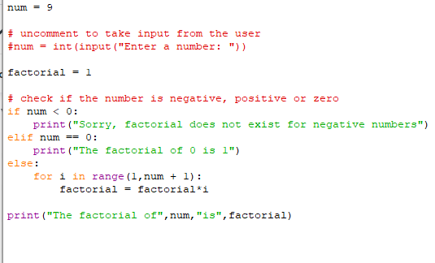

**Output:**

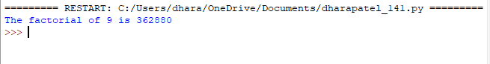

PEP 8 : Coding Style guide in Python

Indeed coding and applying logic is the foundation of any programming language but there’s also another factor that every coder must keep in mind while coding and that is the coding style. Keeping this in mind, Python maintains a strict way of order and format of scripting .Following this sometimes mandatory and is a great help on the user’s end, to understand. Making it easy for others to read code is always a good idea, and adopting a nice coding style helps tremendously for that.

For Python, **PEP 8** has emerged as the style guide that most projects adhere to; it promotes a very readable and eye-pleasing coding style. Every Python developer should read it at some point; here are the most important points extracted for you:

**1. Use 4-space indentation and no tabs.**  
Examples:

The 4-space rule is not always mandatory and can be overruled for continuation line.

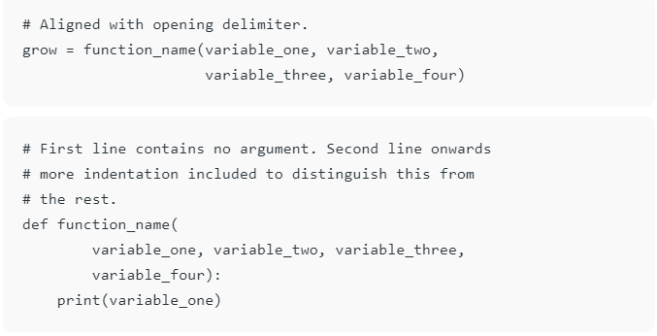

**2. Use docstrings:**There are both single and multi-line docstrings that can be used in Python. However, the single line comment fits in one-line, triple quotes are used in both cases. These are used to define a particular program or define a particular function.  
Example:

**3. Wrap lines so that they don’t exceed 79 characters :**The Python standard library is conservative and requires limiting lines to 79 characters. The lines can be wrapped using parenthesis, brackets, and braces. They should be used in preference to backslashes.  
Example:

**4. Use of regular and updated comments are valuable to both the coders and users** : There are also various types and conditions that if followed can be of great help from programs and users point of view. Comments should form complete sentences. If a comment is a full sentence, its first word should be capitalized, unless it is an identifier that begins with a lower case letter. In short comments, the period at the end can be omitted. In block comments, there are more than one paragraphs and each sentence must end with a period. Block comments and inline comments can be written followed by a single ‘#’.  
Example of inline comments:

**5. Use of trailing commas :** This is not mandatory except while making a tuple.  
**Use Python’s default UTF-8 or ASCII encodings and not any fancy encodings**, if it is meant for international environment.

**6. Use spaces around operators and after commas, but not directly inside bracketing constructs**

**7. Naming Conventions :** There are few naming conventions that should be followed in order to make the program less complex and more readable. At the same time, the naming conventions in Python is a bit of mess, but here are few conventions that can be followed easily.  
There is an overriding principle that follows that the names that are visible to the user as public parts of API should follow conventions that reflect usage rather than implementation.  
Here are few other naming conventions:

.

**8. Characters that should not be used for identifiers :** ‘l’ (lowercase letter el), ‘O’ (uppercase letter oh), or ‘I’ (uppercase letter eye) as single character variable names as these are similar to the numerals one and zero.

**9. Don’t use non-ASCII characters in identifiers**if there is only the slightest chance people speaking a different language will read or maintain the code.  
 **10. Name your classes and functions consistently :**The convention is to use **CamelCase** for classes and **lower_case_with_underscores** for functions and methods. Always use **self** as the name for the first method argument.

**11. While naming of function of methods always use *self* for the first argument** to instance methods and *cls* for the first argument to class methods. If a functions argument name matches with reserved words then it can be written with a trailing comma. For e.g., class_

You can refer to this simple program to know how to write an understandable code:

|  |
| --- |
|  |